**Power BI Assignment : 01**

**Name : Nooras Fatima Ansari**

* **Install Power BI Desktop and share the final screenshot of the report view page which appears when power desktop starts.**

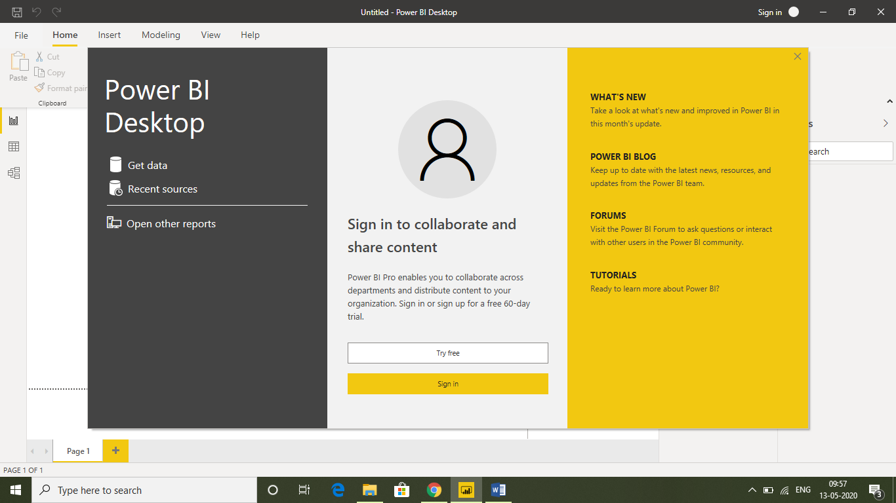

* **Prepare a document and with the following screenshot**
* **Report View**

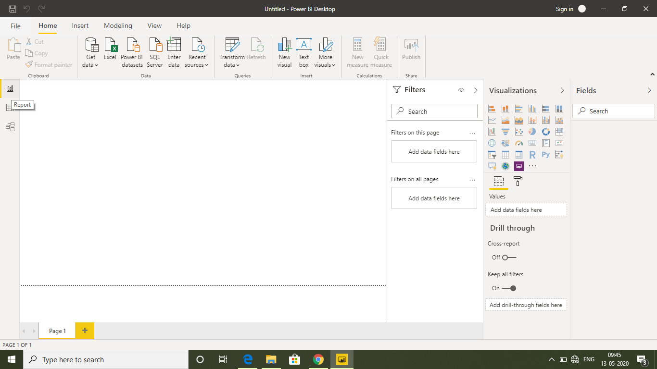

* **Data View**

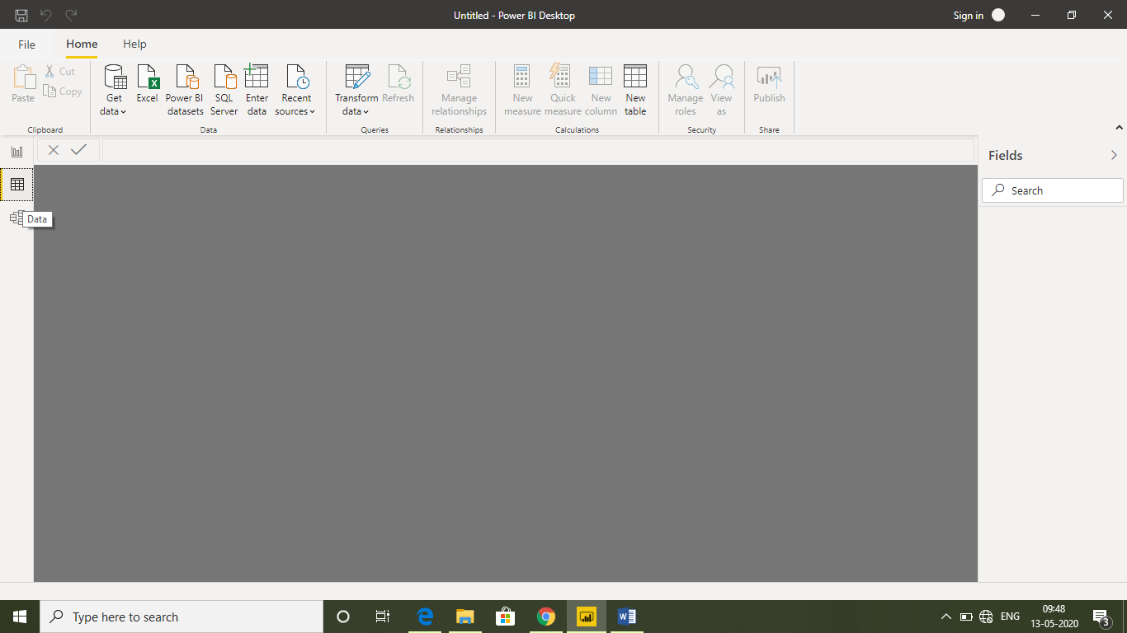

* **Model View**

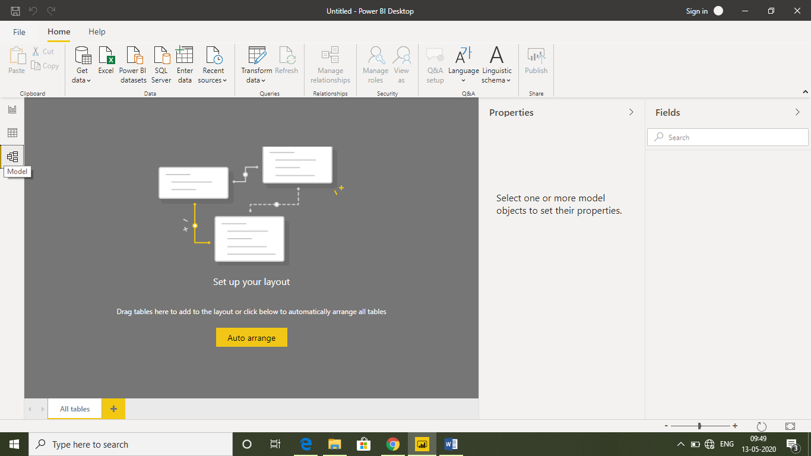

* **Power Query Editor**

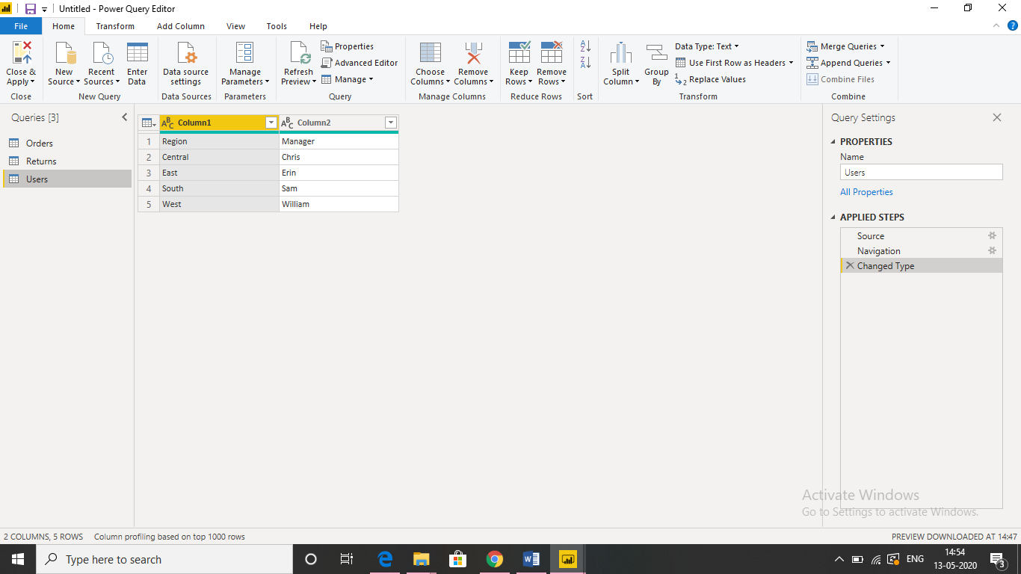

* **Advance Editor**

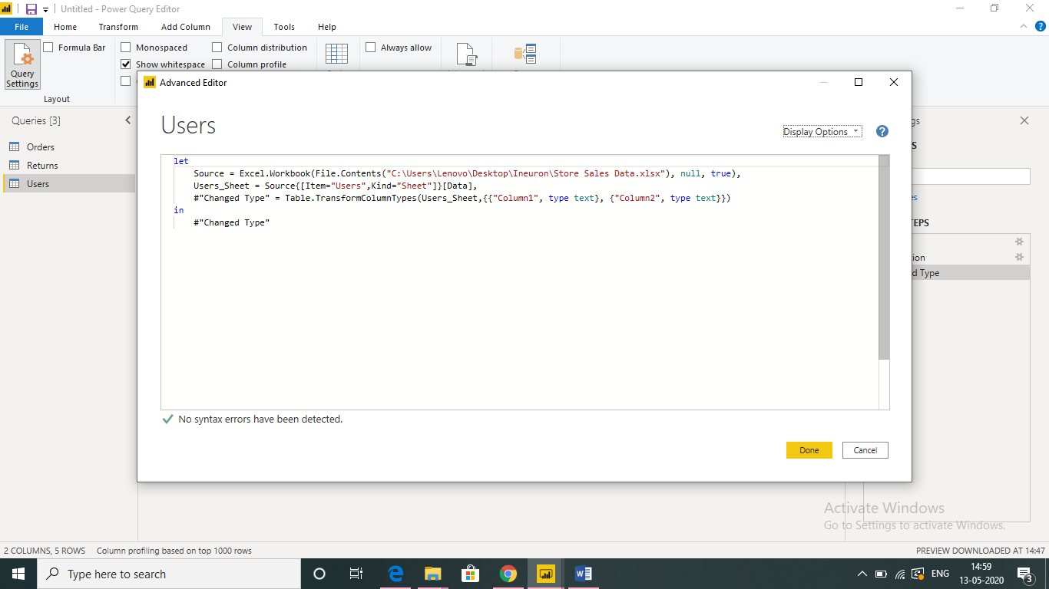

* **Prepare a document with details of the following along with their price**
* **Power BI Desktop –** It is free

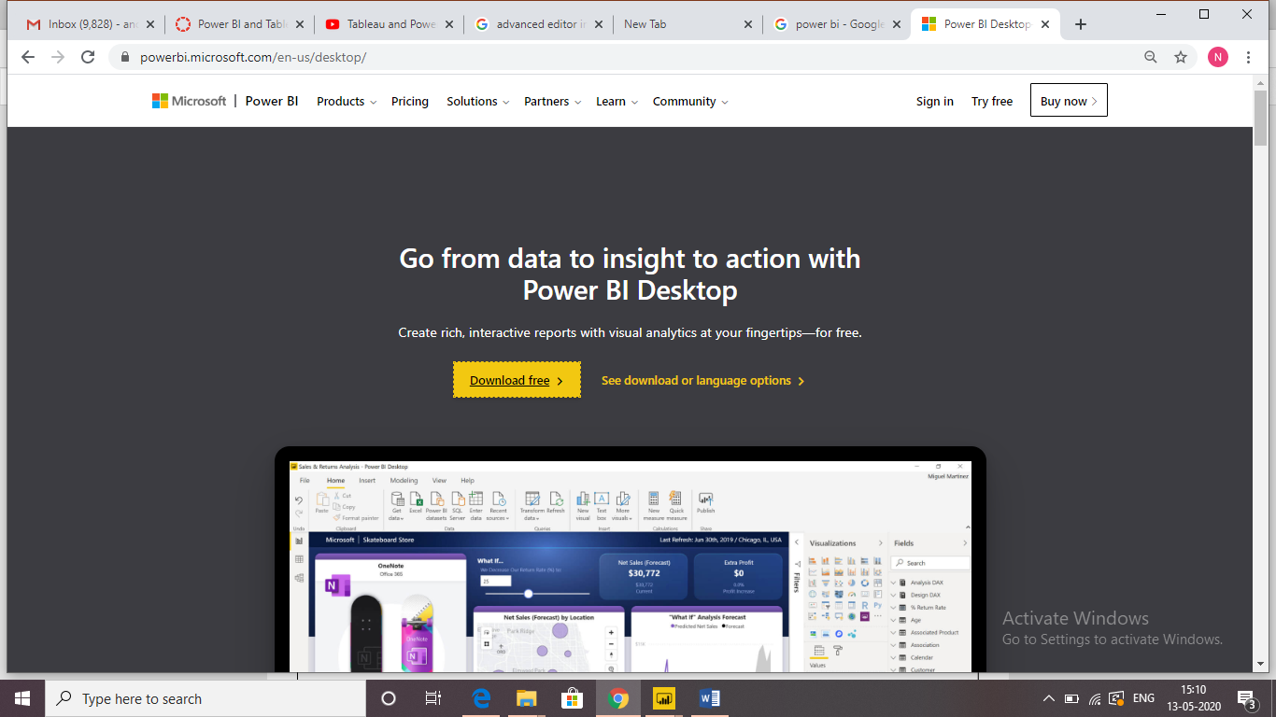

* **Power BI Pro**
* **Power BI Premium**

